- WAP to print hello world
print("Hello World")
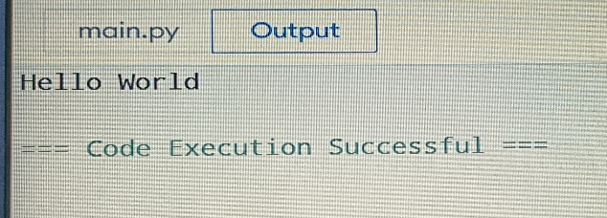
- WAP to add two numbers
a=10
b=20
print(a+b)
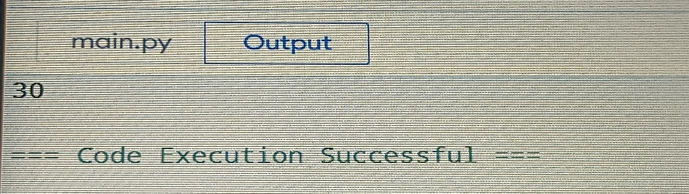
- WAP to Calculate the Area of a Triangle
B = int(input("Enter base:"))
H= int(input("Enter height:"))
Area = 0.5*B*H
print("Area of triangle is:", Area)
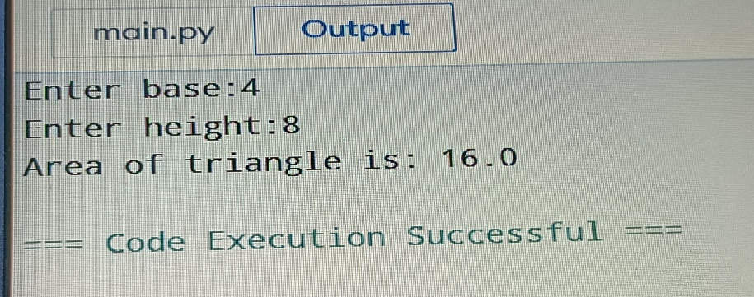
- WAP to input side of a square & print its area.
side = int(input("Enter side of square:"))
Area = side*side
print("Area of square is:", Area)
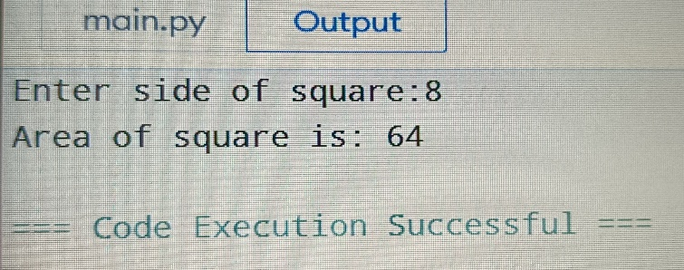
- WAP to input 2 floating point numbers & print their average.
num1 = float(input("Enter first number:"))
num2 = float(input("Enter second number:"))
average = (num1 + num2) / 2
print("Average of the two numbers is:", average)
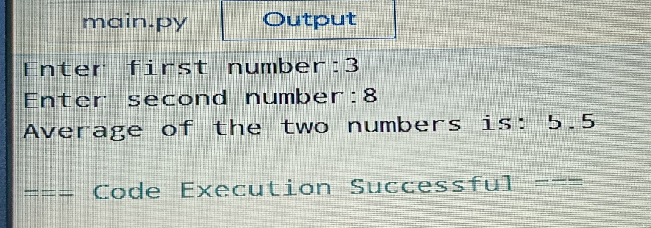
- WAP to input 2 int numbers, a and b. Print True if a is greater than or equal to b. If not print False.
a = int(input("Enter first number:"))
b = int(input("Enter second number:"))
print(a >= b)
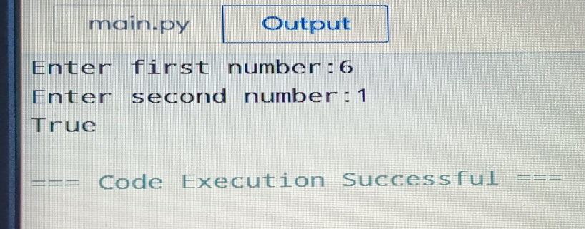
- WAP to input user’s first name & print its length
first_name = input("Enter your first name:")
length = len(first_name)
print("Length of your first name is:", length)
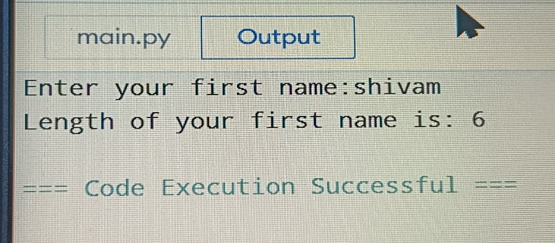

- WAP to find the occurrence of ‘$’ in a String.
string = input("Enter a string:")
count = string.count('$')
print("Occurrence of '$' in the string is:", count)
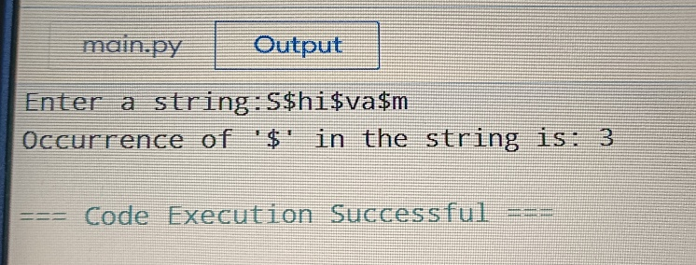
- WAP to check if a number entered by the user is odd or even.
number = int(input("Enter a number:"))
if number % 2 == 0:
print("The number is even.")
else:
print("The number is odd.")
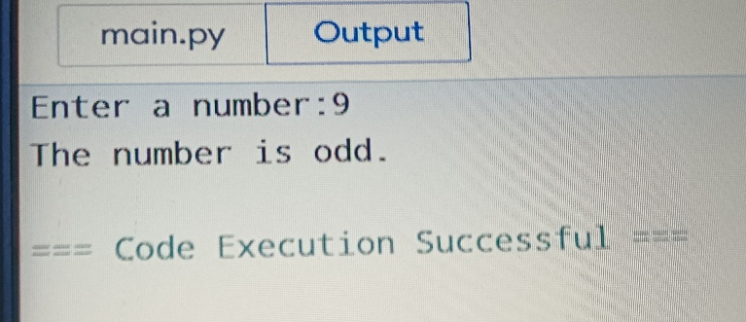
- WAP to find the greatest of 3 numbers entered by the user.
a = int(input("Enter first number:"))
b = int(input("Enter second number:"))
c = int(input("Enter third number:"))
if a >= b and a >= c:
print("The greatest number is:", a)
elif b >= a and b >= c:
print("The greatest number is:", b)
else:
print("The greatest number is:", c)
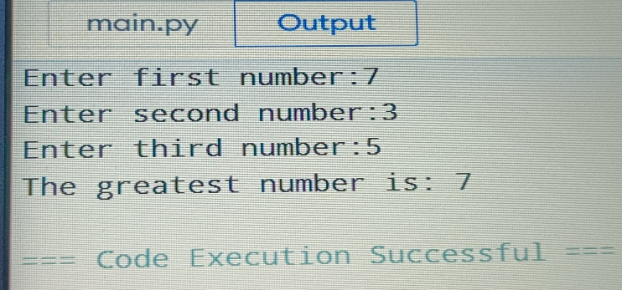
- WAP to check if a number is a multiple of 7 or not.
number = int(input("Enter a number:"))
if number % 7 == 0:
print("The number is a multiple of 7.")
else:
print("The number is not a multiple of 7.")
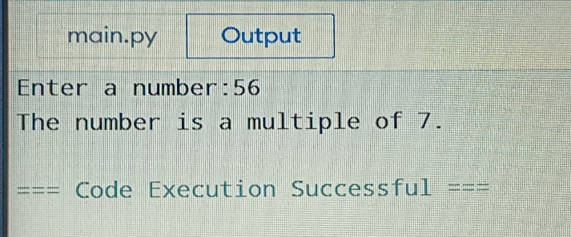

- Write a Program to Find the Square Root
number = float(input("Enter a number:"))
square_root = number ** 0.5
print("The square root of the number is:", square_root)
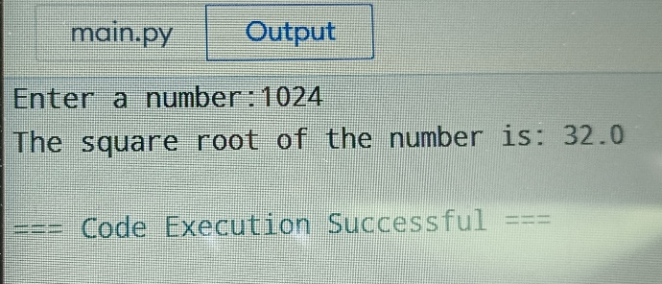
- Python Program to Solve Quadratic Equation
import math
a = float(input("Enter coefficient a:"))
b = float(input("Enter coefficient b:"))
c = float(input("Enter coefficient c:"))
discriminant = b**2 - 4*a*c
if discriminant > 0:
root1 = (-b + math.sqrt(discriminant)) / (2*a)
root2 = (-b - math.sqrt(discriminant)) / (2*a)
print("The roots are real and different.")
print("Root 1 is:", root1)
print("Root 2 is:", root2)
elif discriminant == 0:
root = -b / (2*a)
print("The roots are real and equal.")
print("Root is:", root)
else:
print("The roots are complex.")
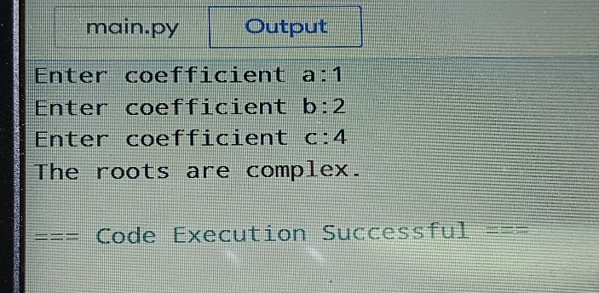
- Python Program to Swap Two Variables
x = 5
y = 10
print("Before swapping: x =", x, "and y =", y)
x, y = y, x
print("After swapping: x =", x, "and y =", y)
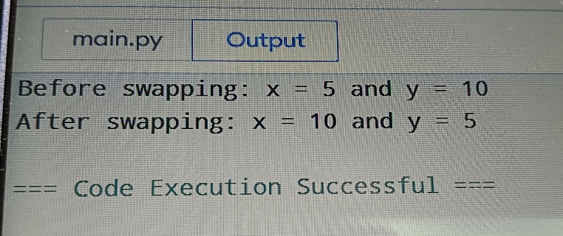
- Python Program to Convert Kilometers to Miles
x= float(input("Enter distance in kilometers:"))
miles = x * 0.621371
print("Distance in miles is:", miles)
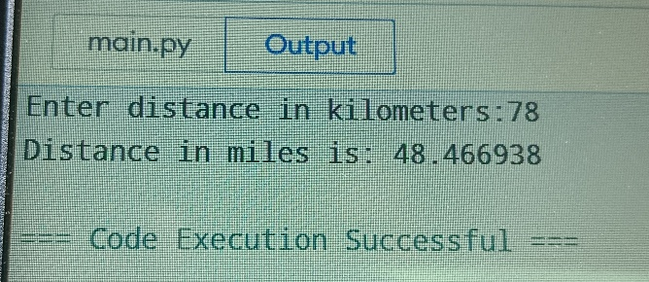
- Python Program to Convert Celsius To Fahrenheit
celsius = float(input("Enter temperature in Celsius:"))
fahrenheit = (celsius * 9/5) + 32
print("Temperature in Fahrenheit is:", fahrenheit)
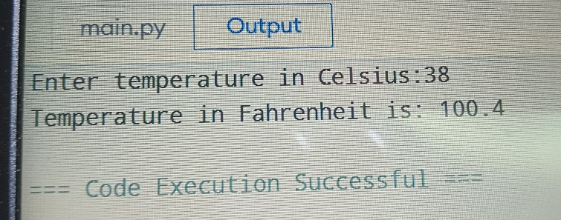
- Python Program to Check if a Number is Positive, Negative or 0
number = float(input("Enter a number:"))
if number > 0:
print("The number is positive.")
elif number < 0:
print("The number is negative.")
else:
print("The number is zero.")
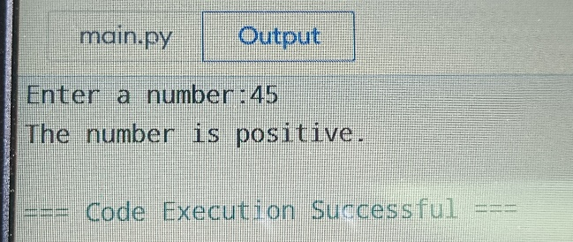
- Python Program to Check Leap Year
year = int(input("Enter a year:"))
if year % 4 == 0:
print("The year is a leap year.")
else:
print("The year is not a leap year.")
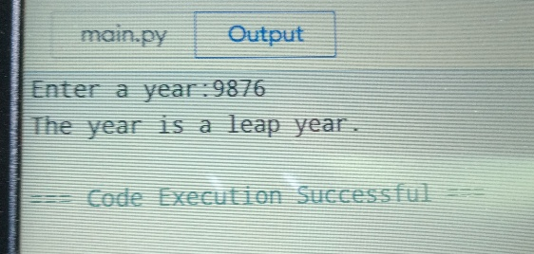
- Python Program to Check Prime Number
number = int(input("Enter a number:"))
is_prime = True
if number > 1:
for i in range(2, number):
if number % i == 0:
is_prime = False
break
else:
is_prime = False
if is_prime:
print("The number is prime.")
else:
print("The number is not prime.")
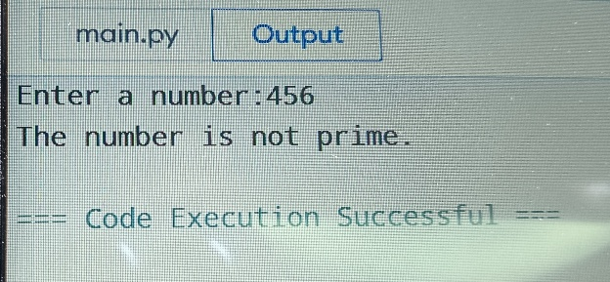
- Python Program to Print all Prime Numbers in an Interval
start = int(input("Enter the start of the interval:"))
end = int(input("Enter the end of the interval:"))
print("Prime numbers in the interval are:")
for number in range(start, end + 1):
is_prime = True
if number > 1:
for i in range(2, number):
if number % i == 0:
is_prime = False
break
else:
is_prime = False
if is_prime:
print(number)
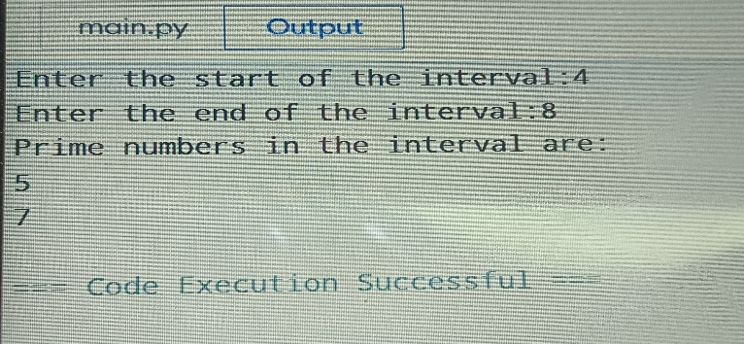
- Python Program to Find the Factorial of a Number
number = int(input("Enter a number:"))
factorial = 1
if number == 0:
print("The factorial of 0 is 1.")
else:
for i in range(1, number + 1):
factorial = factorial * i
print("The factorial of the number is:", factorial)
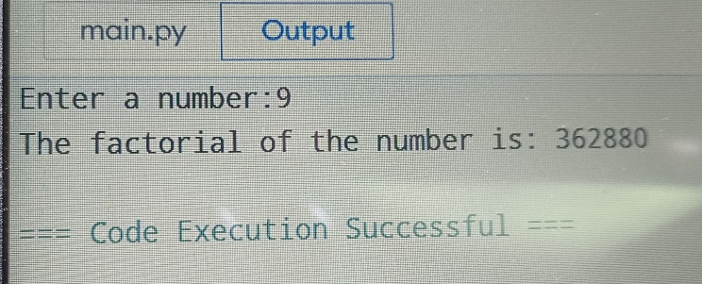
- Python Program to Display the multiplication Table
number = int(input("Enter a number:"))
for i in range(1, 11):
print(number, "x", i, "=", number * i)
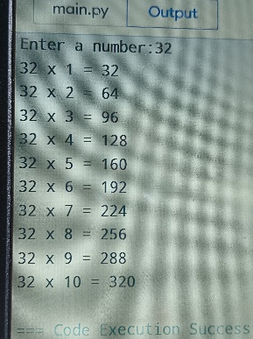
- Python Program to Print the Fibonacci sequence
number = int(input("Enter the number of terms:"))
n1, n2 = 0, 1
count = 0
if number <= 0:
print("Please enter a positive integer.")
elif number == 1:
print("Fibonacci sequence:")
print(n1)
else:
print("Fibonacci sequence:")
while count < number:
print(n1, end=" ")
nth = n1 + n2
n1 = n2
n2 = nth
count += 1
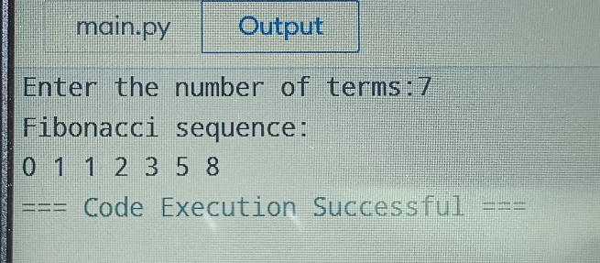
- Python Program to Check Armstrong Number
number = int(input("Enter a number:"))
num_str = str(number)
sum_of_cubes = sum(int(digit) ** 3 for digit in num_str)
if sum_of_cubes == number:
print("The number is an Armstrong number.")
else:
print("The number is not an Armstrong number.")
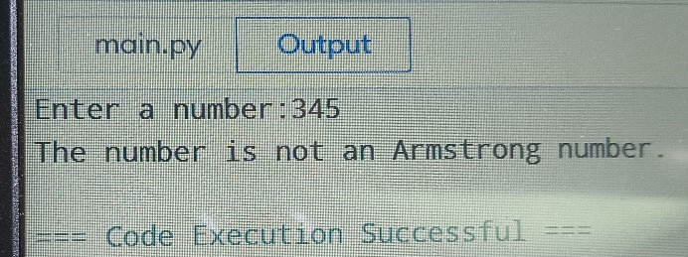
- Python Program to Find Armstrong Number in an Interval
start = int(input("Enter the start of the interval:"))
end = int(input("Enter the end of the interval:"))
print("Armstrong numbers in the interval are:")
for number in range(start, end + 1):
num_str = str(number)
sum_of_cubes = sum(int(digit) ** 3 for digit in num_str)
if sum_of_cubes == number:
print(number)
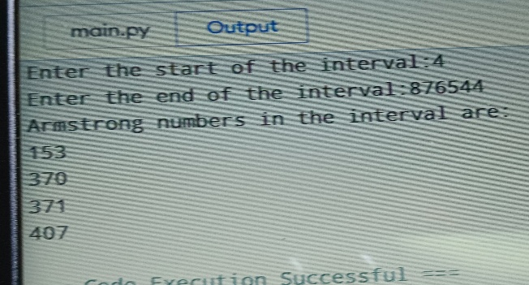
- Python Program to Find the Sum of Natural Numbers
number = int(input("Enter a number:"))
sum_of_natural_numbers = 0
for i in range(1, number + 1):
sum_of_natural_numbers += i
print("The sum of natural numbers up to", number, "is:", sum_of_natural_numbers)
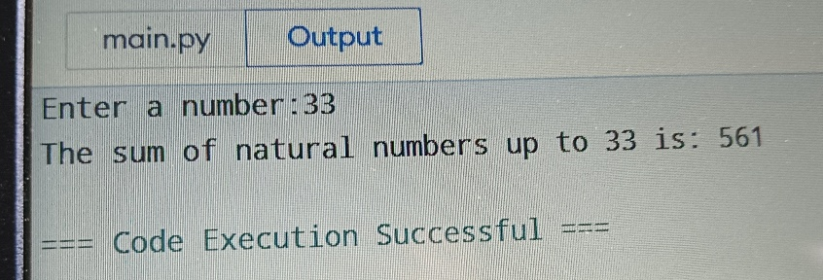
- Python Program to Display Powers of 2 Using Anonymous Function
powers_of_2 = lambda x: 2 ** x
number = int(input("Enter a number:"))
print("Powers of 2 up to", number, "are:")
for i in range(1, number + 1):
print(powers_of_2(i))
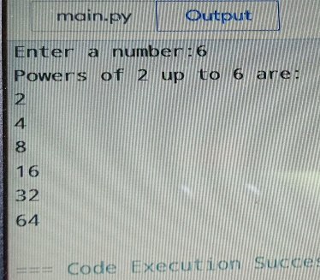
- Python Program to Find Numbers Divisible by Another Number
dividend = int(input("Enter the dividend:"))
divisor = int(input("Enter the divisor:"))
if divisor == 0:
print("Error: Divisor cannot be zero.")
else:
if dividend % divisor == 0:
print(dividend, "is divisible by", divisor)
else:
print(dividend, "is not divisible by", divisor)
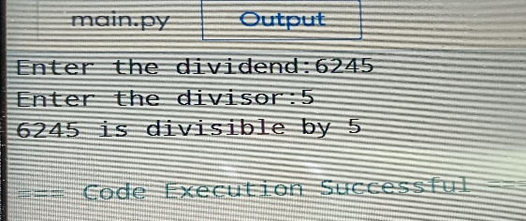
- Python Program to Find ASCII Value of Character
character = input("Enter a character:")
ascii_value = ord(character)
print("The ASCII value of", character, "is", ascii_value)
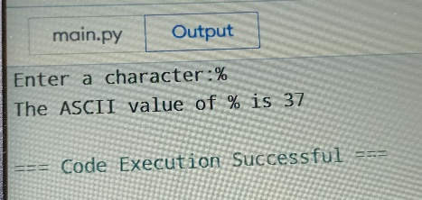
- Python Program to Find HCF
num1 = int(input("Enter the first number:"))
num2 = int(input("Enter the second number:"))
hcf = 1
for i in range(1, min(num1, num2) + 1):
if num1 % i == 0 and num2 % i == 0:
hcf = i
print("The HCF of", num1, "and", num2, "is", hcf)
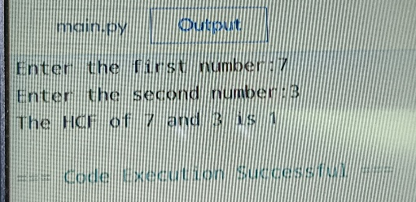
- Python Program to Find LCM
def compute_lcm(x, y):
# choose the greater number
if x > y:
greater = x
else:
greater = y
while(True):
if((greater % x == 0) and (greater % y == 0)):
lcm = greater
break
greater += 1
return lcm
num1 = 54
num2 = 24
print("The L.C.M. is", compute_lcm(num1, num2))
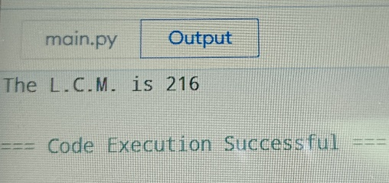
- Python Program to Find the Factors of a Number
number = int(input("Enter a number:"))
print("The factors of", number, "are:")
for i in range(1, number + 1):
if number % i == 0:
print(i)
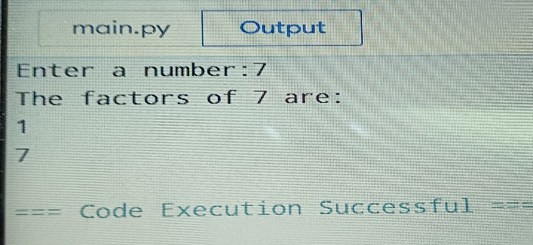
- Python Program to Make a Simple Calculator
print("Select operation:")
print("1. Add")
print("2. Subtract")
print("3. Multiply")
print("4. Divide")
choice = input("Enter choice (1/2/3/4): ")
if choice in ('1', '2', '3', '4'):
num1 = float(input("Enter first number: "))
num2 = float(input("Enter second number: "))
if choice == '1':
print(num1, "+", num2, "=", num1 + num2)
elif choice == '2':
print(num1, "-", num2, "=", num1 - num2)
elif choice == '3':
print(num1, "*", num2, "=", num1 * num2)
elif choice == '4':
if num2 != 0:
print(num1, "/", num2, "=", num1 / num2)
else:
print("Error: Division by zero is not allowed.")
else:
print("Invalid input. Please enter a valid operation.")
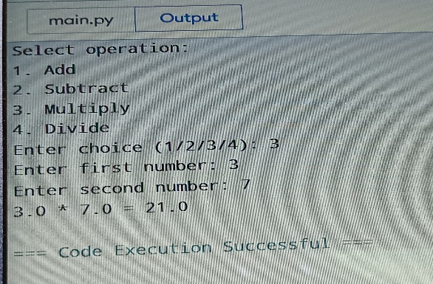
- Python Program to Check Whether a String is Palindrome or Not
string = input("Enter a string: ")
cleaned_string = ''.join(c.lower() for c in string if c.isalnum())
if cleaned_string == cleaned_string[::-1]:
print("The string is a palindrome.")
else:
print("The string is not a palindrome.")
